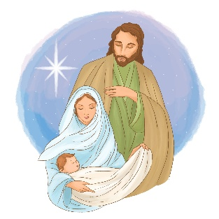

Name:

Parish:

Can you win a prize for the most correct answers in this family
Christmas quiz?

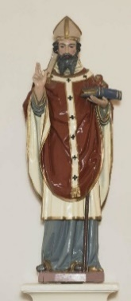
Round 1 – The Christmas Story

- What was the name of the Angel who appeared to Mary to tell her she has been chosen to give birth to the baby Jesus? Gabriel
- In which town did Mary and Joseph live before Jesus was born? Nazareth
- Which animal carried Mary before she gave birth to Jesus? A donkey
- What appeared in the night sky to show the direction for The Three Wise Men to follow? A Star.
- What gifts did The Three Wise Men give Jesus on his birth day? Gold, Frankincense and Myrrh
- Where was baby Jesus born? In Bethlehem
- What was the name of the king who was not happy about the birth of Jesus? King Herod
- When is the Feast of St Stephen? 26th / 27th Dec
- How many candles are there on an Advent wreath, and for an extra point can you tell me what colours they are? 3 purple – represent prayer, penance and preparation, the 1 pink candle represents joy. (some have a 5th White or gold candle that represents Christ).
- Which Christmas Carol brings us ‘Tidings of Comfort and Joy’? God rest ye merry Gentlemen.



Round 2 – Christmas Traditions
- What do people traditionally put on top of a Christmas tree? Angel or star
- Which country did the drink ‘eggnog’ originate from? England
- Which real life person is Father Christmas / Santa Claus based on? The Christian Bishop St Nicholas
- What do children get from Santa if they are on the ‘naughty list’? A lump of coal
- Which country started the tradition of putting up a Christmas tree? Germany
- In which country is it tradition to eat KFC for Christmas Dinner? Japan
- Which creature replaces turkey on the Christmas menu in Hungary? The fish – Carp.
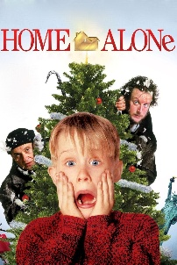
- Which country has a tradition of hiding all broomsticks in the home on Christmas Eve? Norway

Round 3 – Christmas Movies
- In Home Alone, where are the McCallisters going on vacation when they leave Kevin behind? Paris
- In the Christmas movie ‘ How the Grinch Stole Christmas’, the grinch was described with which 3 words. What were they? Stink, stank, stunk.
- In the movie, ‘It’s a wonderful Life’, what happened every time a bell rang? An angel got his wings.
- Which actor played six different roles in the film – The Polar express? Tom Hanks
- In Charles’ Dickens’s A Christmas Carol, what the first name of Scrooge? Ebenezer
- In the movie ‘Elf’, what was the first rule of ‘The Code of Elves?’ Treat Every day like Christmas.
- What feelgood song is everyone dancing to in the final scene of ‘The Holiday’? ‘You Send Me’ by Aretha Franklin


- In Harry Potter and the Philosopher’s Stone, what do the Dursleys give Harry for Christmas? 50p
- The first Die Hard film takes place on Christmas Eve – but in which city? Los Angeles
- What is the name of Kristoff’s reindeer in Frozen? Sven

Round 4 – Christmas songs
- What words follow ‘Silent Night’ in the carol? Holy Night
- Which Christmas song was recorded by Jose Feliciano in 1970, and then more recently by Michale Buble? ‘Feliz Navidad’
- How many gifts in total were given in ‘ The twelve Days of Christmas’ song? 364
- In the classic song ‘We wish you a merry Christmas’, what type of pudding is mentioned? Figgy Pudding
- What is the best-selling Christmas song ever? ‘White Christmas’ by Bing Crosby
- In which year was Mariah Carey’s iconic Christmas hit ‘ All I want for Christmas’ released? 1994
- What comes next in Wham’s Last Christmas song ‘Once bitten and twice as shy, I keep my distance …’? But you still catch my eye.
- Which famous Christmas song includes the lyrics: ‘dashing through the snow, in a one-horse open sleigh?’ Jingle Bells




Round 5 – General Knowledge
- Three of Santa’s reindeers’ names begin with the letter D. What are those names? Dancer, Dasher and Donner.
- This holiday treat was originally designed to resemble a shepherd’s staff. What is it? A candy cane
- In which modern-day country was St Nicholas Born? Turkey
- How many points does a snowflake traditionally have? 6
- What was Frosty the Snowman’s nose made from? Carrot
- Which ocean is Christmas Island in? Indian Ocean
- Which company was the first to use Father Christmas in their advertising? Coca cola
- Mistletoe is associated with Christmas due to its history as a symbol of love and peace. What do people traditionally do under the mistletoe? Kiss
- In which children’s classic is it ‘always winter but never Christmas’? CS Lewis’ The Lion, the Witch and The Wardrobe
- Which country celebrates ‘Noche de las Velitas’ or Night of the Little Candles on the 7th December? Colombia

